Handwriting Analysis Mystery Lab Name:
“Who Signed the Threat?”
Overview
You will act as a forensic document examiner to determine which suspect wrote a threatening note found at a school event. You will compare known handwriting exemplars to a questioned document using forensic features.
Scenario Story
During a school fundraiser, a threatening note was found in the donation box:
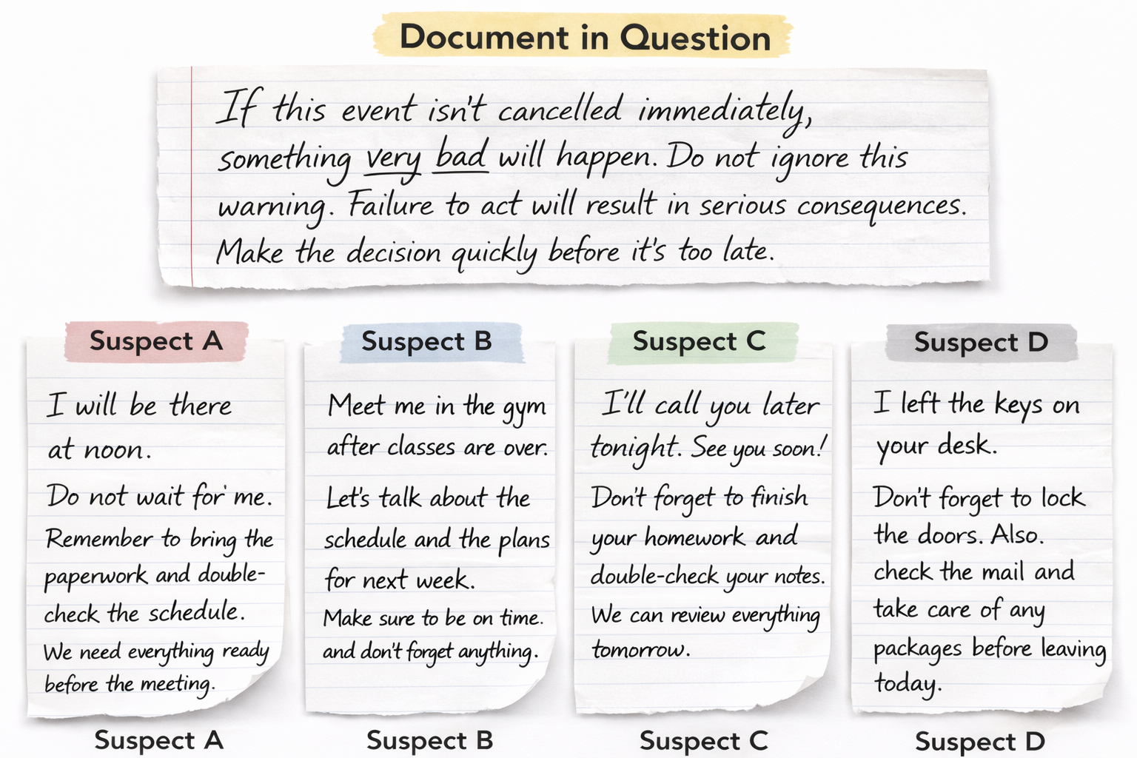

Security identified four possible suspects who had access to the box. You are forensic document examiners tasked with identifying the writer.
Suspects
- Suspect A: Student council member
- Suspect B: Custodian
- Suspect C: Parent volunteer
- Suspect D: Coach
Student Task
- Examine the questioned note
- Compare with each suspect sample
- Analyze handwriting features
- Identify the most likely writer
- Justify with evidence
Suspect Comparison Table
Feature | Questioned Doc | A | B | C | D
Shape
Slant
Size
Spacing
Letter “t”
Unique Features
Contractions
Conclusion
- Which suspect wrote the note?

- Justify your guess by listing as many matching features as you can.

